User registration:

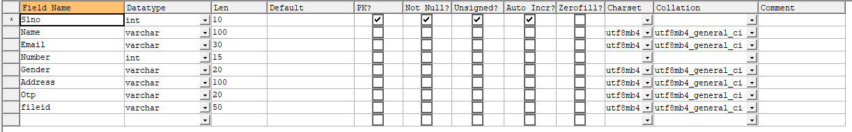

Owner registration:

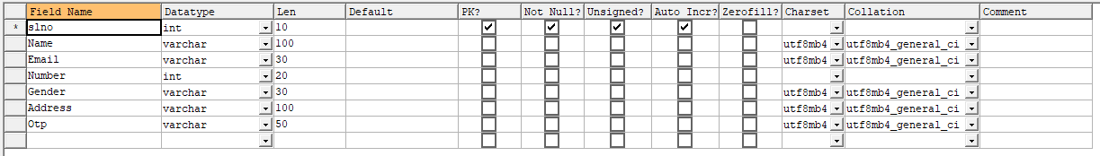

Ownership table:

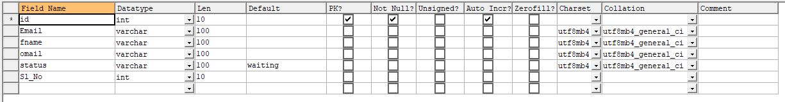

Files upload:

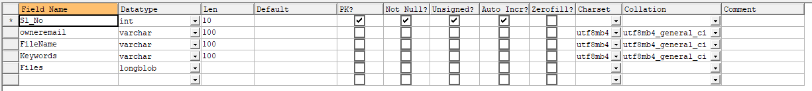

Request table:

